RANK | ILLUSTRATED
- How Does Santa Go Down the Chimney?
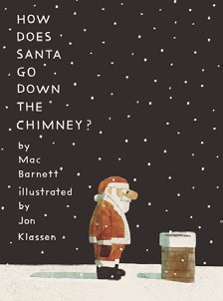



Mac Barnett, Jon Klassen (Illus.), Candlewick, $18.99
- How the Grinch Stole Christmas!
Dr. Seuss, Random House Books for Young Readers,
$19.99
- Santa’s First Christmas
Mac Barnett, Sydney Smith (Illus.), Viking Books for Young Readers, $18.99
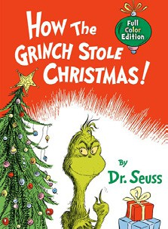

- The Polar Express
Chris Van Allsburg, HMH Books for Young Readers,
$21.99
- Alice in a Winter Wonderland
Jan Brett, G.P. Putnam’s Sons Books for Young Readers, $19.99
- The Snowy Day
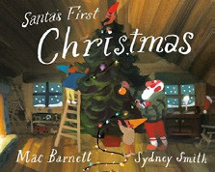

Ezra Jack Keats, Viking Books for Young Readers,
$19.99
- Knight Owl and Early Bird
Christopher Denise, Christy Ottaviano Books, $18.99


- The Mitten
Jan Brett, G.P. Putnam’s Sons Books for Young Readers, $9.99
- The Bakery Dragon
Devin Elle Kurtz, Knopf Books for Young Readers,
$18.99
- Don’t Let the Pigeon Drive the Sleigh!
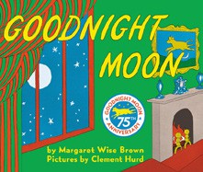

Mo Willems, Union Square Kids, $18.99
- Little Blue Truck’s Christmas
Alice Schertle, Jill McElmurry (Illus.), HMH Books for Young Readers, $18.99
- Where’s Bluey? At Christmas
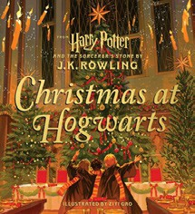

Penguin Young Readers, $8.99
- Chicka Chicka Ho Ho Ho
William Boniface, Julien Chung (Illus.), Beach Lane Books, $18.99
- Goodnight Moon
Margaret Wise Brown, Clement Hurd (Illus.), Harper,
$10.99
- Christmas at Hogwarts
J. K. Rowling, Ziyi Gao (Illus.), Scholastic, $19.99
December 18, 2024
For the week ending December 15, 2024 based on sales in hundreds of independent bookstores nationwide.
CHILDREN’S

RANK | SERIES
  - Dog Man (hardcover)


Dav Pilkey, Graphix
  - The Wild Robot
Peter Brown, Little, Brown Books for Young Readers
  - Diary of a Wimpy Kid (hardcover)
Jeff Kinney, Harry N. Abrams
  - Percy Jackson and the Olympians


Rick Riordan, Hyperion
  - Elephant & Piggie (hardcover)
Mo Willems, Hyperion
  - Wings of Fire
Tui T. Sutherland, Scholastic
  - Magic Tree House
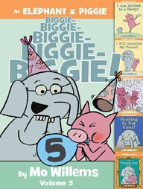

Mary Pope Osborne, Sal Murdocca (Illus.), Random House Books for Young Readers
  - Keeper of the Lost Cities
Shannon Messenger, Aladdin
  - The Bad Guys (paperback)
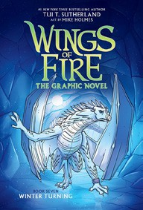

Aaron Blabey, Scholastic
  - I Survived
Lauren Tarshis, Dave Shephard (Illus.), Scholastic

All Fiction Series titles are hardcover and
paperback unless noted.
Debut


Indies Introduce

OTHER CHILDREN’S INDIE FAVORITES
AGES 4 TO 8
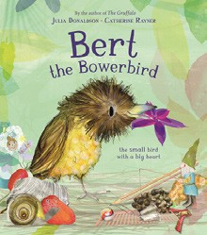

Bert, the Bowerbird: The Small Bird with a Big Heart Julia Donaldson, Catherine Rayner (Illus.), Boxer Books, $18.99 “With adorable rhymes from Julia Donaldson (author of The Gruffalo and Room on the Broom) and gorgeous illustrations by Catherine Rayner, Bert, the Bowerbird is a wonderful tale of bird-based romance and self-acceptance. Don’t settle, Bert!”
—Charlie Marks, Fountain Bookstore, Richmond, VA

