RANK | HARDCOVER

- James




Percival Everett, Doubleday, $28
- Small Things Like These
Claire Keegan, Grove Press, $20
- The God of the Woods
Liz Moore, Riverhead Books, $30
- Wind and Truth
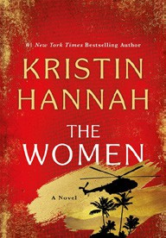

Brandon Sanderson, Tor Books, $39.99
- The Women
Kristin Hannah, St. Martin’s Press, $30
- Intermezzo
Sally Rooney, Farrar, Straus and Giroux, $29
- The City and Its Uncertain Walls


Haruki Murakami, Knopf, $35
- All Fours
Miranda July, Riverhead Books, $29
- Playground
Richard Powers, W. W. Norton & Company, $29.99
- The Grey Wolf


Louise Penny, Minotaur Books, $30
- The Wedding People
Alison Espach, Henry Holt and Co., $28.99
- Tell Me Everything
Elizabeth Strout, Random House, $30
- Martyr!
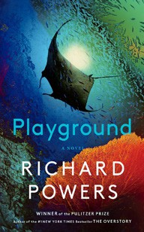

Kaveh Akbar, Knopf, $28
- The Mighty Red
Louise Erdrich, Harper, $32
- We Solve Murders
Richard Osman, Pamela Dorman Books, $30
December 18, 2024
For the week ending December 15, 2024 based on sales in hundreds of independent bookstores nationwide.
FICTION

RANK | PAPERBACK
  - Orbital


Samantha Harvey, Grove Press, $17
  - The Frozen River
Ariel Lawhon, Vintage, $18
  - Demon Copperhead
Barbara Kingsolver, Harper Perennial, $21.99
  - Wicked
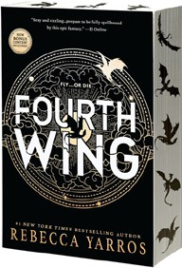

Gregory Maguire, William Morrow Paperbacks,
$19.99
  - North Woods
Daniel Mason, Random House Trade Paperbacks,
$18
  - Fourth Wing


Rebecca Yarros, Entangled: Red Tower Books, $20.99
  - The Berry Pickers
Amanda Peters, Catapult, $17.95
  - Tomorrow, and Tomorrow, and Tomorrow
Gabrielle Zevin, Vintage, $19
  - A Court of Thorns and Roses
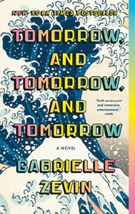

Sarah J. Maas, Bloomsbury Publishing, $19
  - The Hunter
Tana French, Penguin, $19
  - Hello Beautiful
Ann Napolitano, Dial Press Trade Paperback,
$18.99
  - The Thursday Murder Club


Richard Osman, Penguin, $18
  - Devotions
Mary Oliver, Penguin, $20
  - The Best American Short Stories 2024
Lauren Groff, Heidi Pitlor (Eds.), Mariner Books,
$19.99
  - The Vegetarian
Han Kang, Hogarth, $17

Debut
On the Rise Indies Introduce

