April 2, 2025


For the week ending March 30, 2025 based on sales in hundreds of independent bookstores nationwide.
CHILDREN’S

RANK | SERIES

RANK | ILLUSTRATED

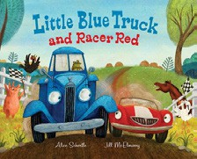
- Little Blue Truck and Racer Red
Alice Schertle, Jill McElmurry (Illus.), Clarion Books,
$19.99
- Goodnight Moon
Margaret Wise Brown, Clement Hurd (Illus.), Harper,
$10.99
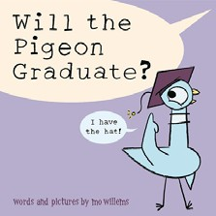

- The Very Hungry Caterpillar
Eric Carle, World of Eric Carle, $10.99
- Will the Pigeon Graduate?
Mo Willems, Union Square Kids, $18.99
- Where the Wild Things Are
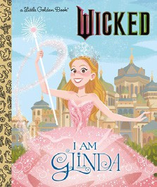

Maurice Sendak, Harper, $21.99
- I Am Glinda (Little Golden Book)
Mary Man-Kong, Elsa Chang (Illus.), Golden Books,
$5.99
- Dragons Love Tacos
Adam Rubin, Daniel Salmieri (Illus.), Dial Books,
$18.99
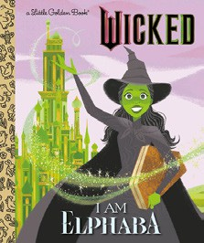

- Little Blue Truck
Alice Schertle, Jill McElmurry (Illus.), Clarion Books,
$10.99
- I Am Elphaba (Little Golden Book)
Mary Man-Kong, Elsa Chang (Illus.), Golden Books,
$5.99
- Brown Bear, Brown Bear, What Do You See? Bill Martin, Jr., Eric Carle (Illus.), Henry Holt and Co. BYR, $8.99
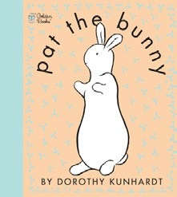

- Pat the Bunny
Dorothy Kunhardt, Golden Books, $9.99
- Dragon’s First Taco
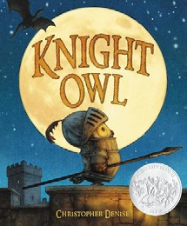

Adam Rubin, Daniel Salmieri (Illus.), Dial Books,
$8.99
- Knight Owl and Early Bird
Christopher Denise, Christy Ottaviano Books, $18.99
- The Going to Bed Book
Sandra Boynton, Boynton Bookworks, $6.99
- Knight Owl
Christopher Denise, Christy Ottaviano Books, $17.99
  - The Hunger Games
Suzanne Collins, Scholastic Press
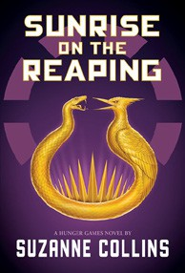

  - Dog Man (hardcover)
Dav Pilkey, Graphix
  - Wings of Fire
Tui T. Sutherland, Mike Holmes (Illus.), Scholastic
  - Diary of a Wimpy Kid (hardcover)
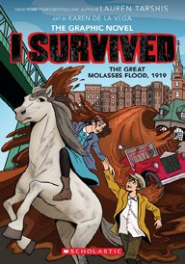

Jeff Kinney, Harry N. Abrams
  - The Wild Robot
Peter Brown, Little, Brown Books for Young Readers
  - InvestiGators (hardcover)
John Patrick Green, Christopher Hastings, Pat Lewis (Illus.), First Second
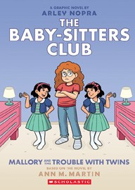

  - I Survived
Lauren Tarshis, Karen De la Vega (Illus.), Scholastic
  - Elephant & Piggie (hardcover)
Mo Willems, Hyperion
  - Baby-Sitters Club Graphix
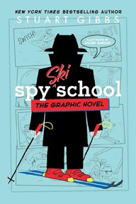

Ann M. Martin, Arley Nopra (Illus.), Scholastic
  - Spy School
Stuart Gibbs, Anjan Sarkar (Illus.), Simon & Schuster Books for Young Readers

All Fiction Series titles are hardcover and
paperback unless noted.
Debut


Indies Introduce

OTHER CHILDREN’S INDIE FAVORITES
AGES 4 TO 8
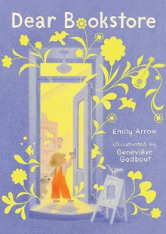

Dear Bookstore
Emily Arrow, Geneviève Godbout (Illus.), Candlewick, $17.99 “No picture book has so beautifully captured the magic
and belonging of bookstores quite like this one. I teared up through the entire read and I’m sure you will, too.”
—Jordan Leon, Lion’s Mouth Bookstore, Green Bay, WI

