RANK | HARDCOVER

- James
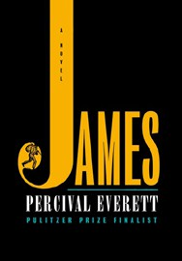



Percival Everett, Doubleday, $28
- The God of the Woods
Liz Moore, Riverhead Books, $30
- Wild Dark Shore
Charlotte McConaghy, Flatiron Books, $28.99
- The Wedding People
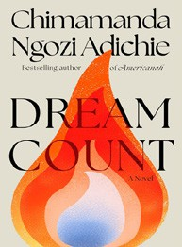

Alison Espach, Henry Holt and Co., $28.99
- Dream Count
Chimamanda Ngozi Adichie, Knopf, $32
- Onyx Storm (Standard Edition)
Rebecca Yarros, Entangled: Red Tower Books, $29.99
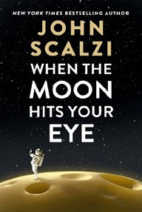

- Iron Flame
Rebecca Yarros, Entangled: Red Tower Books, $29.99
- Broken Country
Clare Leslie Hall, Simon & Schuster, $28.99
- The Antidote
Karen Russell, Knopf, $30
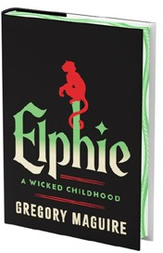
- The Buffalo Hunter Hunter
Stephen Graham Jones, S&S/Saga Press, $29.99
- When the Moon Hits Your Eye
John Scalzi, Tor Books, $29.99
- Small Things Like These
Claire Keegan, Grove Press, $20
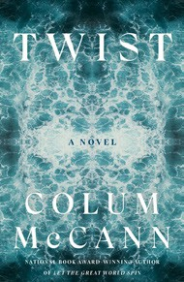
- Elphie (Deluxe Limited Edition)
Gregory Maguire, William Morrow, $30
- The Women
Kristin Hannah, St. Martin’s Press, $30
- Twist
Colum McCann, Random House, $28
April 2, 2025
For the week ending March 30, 2025 based on sales in hundreds of independent bookstores nationwide.
FICTION

RANK | PAPERBACK
  - Martyr!
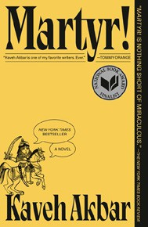

Kaveh Akbar, Vintage, $18
  - Funny Story
Emily Henry, Berkley, $19
  - The Frozen River
Ariel Lawhon, Vintage, $18
  - Orbital
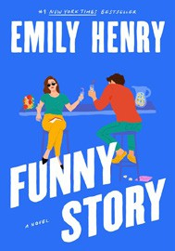

Samantha Harvey, Grove Press, $17
  - Demon Copperhead
Barbara Kingsolver, Harper Perennial, $21.99
  - Fourth Wing
Rebecca Yarros, Entangled: Red Tower Books, $20.99
  - Parable of the Sower
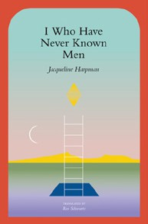

Octavia E. Butler, Grand Central, $19.99
  - Deep End
Ali Hazelwood, Berkley, $20
  - North Woods
Daniel Mason, Random House Trade Paperbacks, $18
  - The Handmaid’s Tale
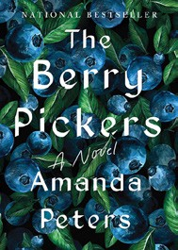

Margaret Atwood, Anchor, $18
  - A Court of Thorns and Roses
Sarah J. Maas, Bloomsbury Publishing, $19
  - I Who Have Never Known Men
Jacqueline Harpman, Transit Books, $16.95
  - The Housemaid
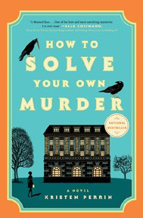

Freida McFadden, Grand Central, $12.99
  - The Crash
Freida McFadden, Poisoned Pen Press, $17.99
  - The Berry Pickers
Amanda Peters, Catapult, $17.95
17 How to Solve Your Own Murder

Kristen Perrin, Dutton, $18

Debut
On the Rise Indies Introduce

