RANK | FICTION
- James
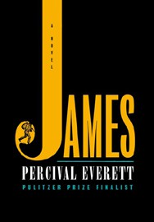



Percival Everett, Doubleday, $28
- The God of the Woods
Liz Moore, Riverhead Books, $30
- Wild Dark Shore
Charlotte McConaghy, Flatiron Books, $28.99
- The Wedding People
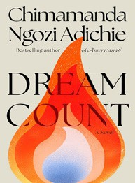

Alison Espach, Henry Holt and Co., $28.99
- Dream Count
Chimamanda Ngozi Adichie, Knopf, $32
- Onyx Storm (Standard Edition)
Rebecca Yarros, Entangled: Red Tower Books, $29.99
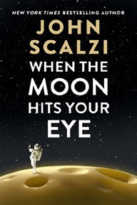

- Iron Flame
Rebecca Yarros, Entangled: Red Tower Books, $29.99
- Broken Country
Clare Leslie Hall, Simon & Schuster, $28.99
- The Antidote
Karen Russell, Knopf, $30
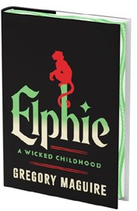
- The Buffalo Hunter Hunter
Stephen Graham Jones, S&S/Saga Press, $29.99
- When the Moon Hits Your Eye
John Scalzi, Tor Books, $29.99
- Small Things Like These
Claire Keegan, Grove Press, $20
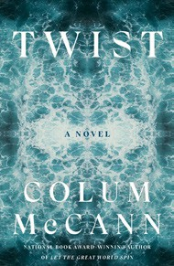
- Elphie (Deluxe Limited Edition)
Gregory Maguire, William Morrow, $30
- The Women
Kristin Hannah, St. Martin’s Press, $30
- Twist
Colum McCann, Random House, $28
April 2, 2025
For the week ending March 30, 2025 based on sales in hundreds of independent bookstores nationwide.
HARDCOVER

RANK | NONFICTION
  - Everything Is Tuberculosis (Signed Edition): The History and Persistence of Our Deadliest Infection
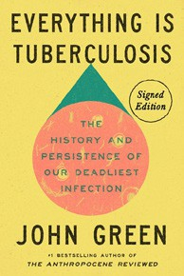

John Green, Crash Course Books, $28
  - The Let Them Theory
Mel Robbins, Sawyer Robbins, Hay House LLC, $29.99
  - Careless People
Sarah Wynn-Williams, Flatiron Books, $32.99
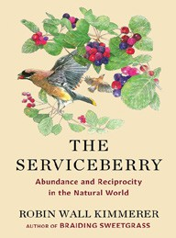

  - The Serviceberry
Robin Wall Kimmerer, John Burgoyne (Illus.), Scribner, $20
  - Abundance
Ezra Klein, Derek Thompson, Avid Reader Press/ Simon & Schuster, $30
  - One Day, Everyone Will Have Always Been Against This
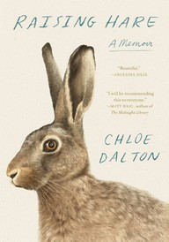

Omar El Akkad, Knopf, $28
  - The Tell: A Memoir
Amy Griffin, The Dial Press, $29
  - Raising Hare: A Memoir
Chloe Dalton, Pantheon, $27
  - Who Is Government?


Michael Lewis (Ed.), Riverhead Books, $30
  - Everything Is Tuberculosis (Standard Edition)
John Green, Crash Course Books, $28
  - Memorial Days: A Memoir
Geraldine Brooks, Viking, $28
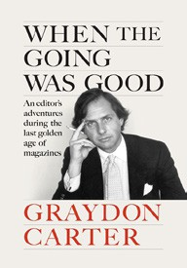
  - The Anxious Generation
Jonathan Haidt, Penguin Press, $30
  - The Creative Act: A Way of Being
Rick Rubin, Penguin Press, $32
  - When the Going Was Good: An Editor’s Adventures During the Last Golden Age of Magazines
Graydon Carter, Penguin Press, $32
  - Atomic Habits
James Clear, Avery, $27

OTHER HARDCOVER INDIE FAVORITES
Debut
On the Rise


Indies Introduce

Deep Cuts: A Novel
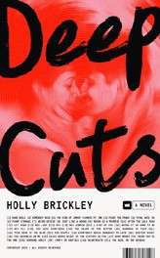

Holly Brickley, Crown, $28
“This book is a love song. It’s a love letter to music, to connection, to friendship and romance and collaboration and connection and talent and pain. I wish I could have written this book. I’m jealous of people who haven’t read this book yet.”
—Jamie Thomas, Women & Children First, Chicago, IL
Count My Lies: A Novel
Sophie Stava, Gallery/Scout Press, $28.99
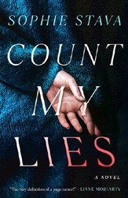

“Count My Lies is an absolute thrill ride! A woman lies her way into the lives of a couple and their young daughter. But is she the only one keeping secrets? Order some take-out and settle in. Once you start reading, it’s impossible to stop!”
—Mary O’Malley, Skylark Bookshop, Columbia, MO

