RANK | EARLY & MIDDLE GRADE
- Impossible Creatures
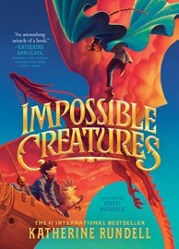



Katherine Rundell, Ashley Mackenzie (Illus.), Knopf Books for Young Readers, $19.99
- A Wolf Called Fire
Rosanne Parry, Mónica Armiño (Illus.), Greenwillow Books, $18.99
- A Song for You and I: A Graphic Novel
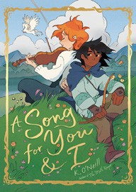

K. O’Neill, Random House Graphic, $13.99
- Warriors Graphic Novel #1
Erin Hunter, Natalie Riess (Illus.), Sara Goetter (Illus.), HarperAlley, $15.99
- The Lost Library
Rebecca Stead, Wendy Mass, Square Fish, $8.99
- Drama: A Graphic Novel
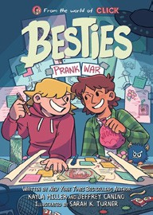

Raina Telgemeier, Graphix, $12.99
- The New Girl: A Graphic Novel
Cassandra Calin, Graphix, $12.99
- Resist: A Story of D-Day
Alan Gratz, Scholastic Press, $9.99
- The One and Only Bob
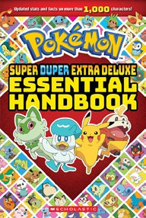

Katherine Applegate, Patricia Castelao (Illus.), Harper, $10.99
- The Squad: A Graphic Novel
Christina Soontornvat, Joanna Cacao (Illus.), Graphix, $12.99
- The Bletchley Riddle
Ruta Sepetys, Steve Sheinkin, Viking Books for Young Readers, $18.99
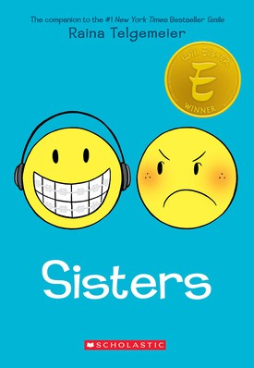

- Besties: Prank War
Kayla Miller, Sarah K. Turner (Illus.), Jeffrey Canino, Clarion Books, $15.99
- Super Duper Extra Deluxe Essential Handbook (Pokémon)
Scholastic, $16.99
- Smile: A Graphic Novel
Raina Telgemeier, Graphix, $12.99
- Sisters: A Graphic Novel
Raina Telgemeier, Graphix, $12.99
April 2, 2025
For the week ending March 30, 2025 based on sales in hundreds of independent bookstores nationwide.
CHILDREN’S

RANK | YOUNG ADULT
  - Our Infinite Fates (Deluxe Limited Edition)
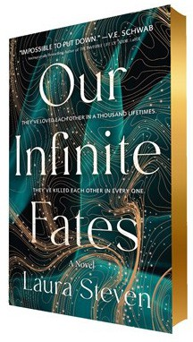

Laura Steven, Wednesday Books, $20
  - Powerless
Lauren Roberts, Simon & Schuster Books for Young Readers, $19.99
  - Better Than the Movies
Lynn Painter, Simon & Schuster Books for Young Readers, $12.99
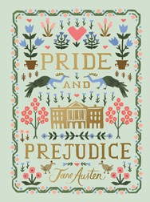

  - Pride and Prejudice
Jane Austen, Anna Bond (Illus.), Puffin Books, $17
  - Rebel Witch: The Crimson Moth: Book 2
Kristen Ciccarelli, Wednesday Books, $20
  - If Only I Had Told Her
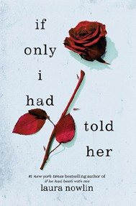

Laura Nowlin, Sourcebooks Fire, $12.99
  - If He Had Been with Me
Laura Nowlin, Sourcebooks Fire, $10.99
  - Wings of Starlight
Allison Saft, Disney Press, $18.99
  - Heartless Hunter: The Crimson Moth: Book 1
Kristen Ciccarelli, Wednesday Books, $20
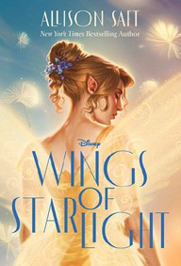

  - The Outsiders
S. E. Hinton, Viking Books for Young Readers, $14.99
  - Betting on You
Lynn Painter, Simon & Schuster Books for Young Readers, $12.99
  - Reckless
Lauren Roberts, Simon & Schuster Books for Young Readers, $21.99
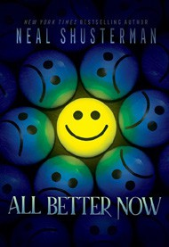

  - Nothing Like the Movies
Lynn Painter, Simon & Schuster Books for Young Readers, $19.99
  - All Better Now
Neal Shusterman, Simon & Schuster Books for Young Readers, $21.99
  - The Book Thief
Markus Zusak, Knopf Books for Young Readers, $14.99
Debut


OTHER CHILDREN’S INDIE FAVORITES ^{Indies} ^{Introduce}
AGES 8 TO 12 TEEN READERS
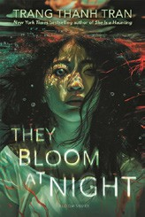

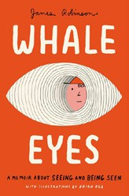

Whale Eyes: A Memoir About Seeing and Being Seen James Robinson, Brian Rea (Illus.), Penguin Workshop, $18.99 “Whale Eyes is an essential text for helping us to further understand the way that we as a society treat disabled kids by putting us in their shoes. If you have ever been ostracized and treated poorly because of ableism, you will feel seen by this story.”
—Ava Budavari, All She Wrote Books, Somerville, MA
They Bloom at Night
Trang Thanh Tran, Bloomsbury YA, $19.99
“Noon and her mom are living on a houseboat after a natural disaster and red algae have decimated their town. As Noon confronts her past as well as her current situation, the question is: who really is the monster? This will resonate for readers of SPEAK.”
—Audrey I-Wei Huang, Belmont Books, Belmont, MA

