RANK | HARDCOVER

- Everything Is Tuberculosis (Signed Edition): The History and Persistence of Our Deadliest Infection




John Green, Crash Course Books, $28
- The Let Them Theory
Mel Robbins, Sawyer Robbins, Hay House LLC, $29.99
- Careless People
Sarah Wynn-Williams, Flatiron Books, $32.99
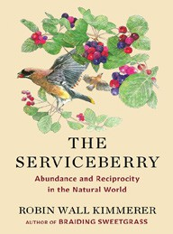

- The Serviceberry
Robin Wall Kimmerer, John Burgoyne (Illus.), Scribner, $20
- Abundance
Ezra Klein, Derek Thompson, Avid Reader Press/ Simon & Schuster, $30
- One Day, Everyone Will Have Always Been Against This


Omar El Akkad, Knopf, $28
- The Tell: A Memoir
Amy Griffin, The Dial Press, $29
- Raising Hare: A Memoir
Chloe Dalton, Pantheon, $27
- Who Is Government?


Michael Lewis (Ed.), Riverhead Books, $30
- Everything Is Tuberculosis (Standard Edition)
John Green, Crash Course Books, $28
- Memorial Days: A Memoir
Geraldine Brooks, Viking, $28
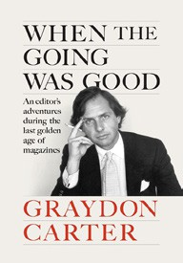
- The Anxious Generation
Jonathan Haidt, Penguin Press, $30
- The Creative Act: A Way of Being
Rick Rubin, Penguin Press, $32
- When the Going Was Good: An Editor’s Adventures During the Last Golden Age of Magazines
Graydon Carter, Penguin Press, $32
- Atomic Habits
James Clear, Avery, $27
April 2, 2025
For the week ending March 30, 2025 based on sales in hundreds of independent bookstores nationwide.
NONFICTION

RANK | PAPERBACK

  - On Tyranny: Twenty Lessons from the Twentieth Century
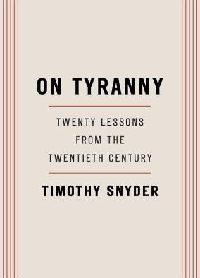

Timothy Snyder, Crown, $12
  - The Wager
David Grann, Vintage, $21
  - Braiding Sweetgrass
Robin Wall Kimmerer, Milkweed Editions, $20


  - The Backyard Bird Chronicles
Amy Tan, Knopf, $36
  - The Art Thief
Michael Finkel, Vintage, $18
  - All About Love: New Visions
bell hooks, Morrow, $16.99
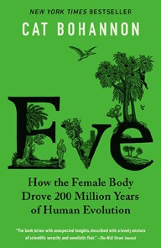

  - Eve
Cat Bohannon, Vintage, $20
  - A Dumb Birds Field Guide to the Worst Birds Ever
Matt Kracht, Chronicle Books, $15.95
  - The Portable Feminist Reader

Roxane Gay (Ed.), Penguin Classics, $25
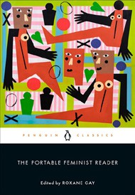

  - The Body Keeps the Score
Bessel van der Kolk, M.D., Penguin, $19
  - On Tyranny Graphic Edition
Timothy Snyder, Nora Krug (Illus.), Ten Speed Graphic, $16.99
  - The Hundred Years’ War on Palestine


Rashid Khalidi, Metropolitan Books, $19.99
  - The Artist’s Way: 30th Anniversary Edition
Julia Cameron, TarcherPerigee, $20
  - A People’s History of the United States
Howard Zinn, Harper Perennial Modern Classics, $22.99
  - There’s Always This Year: On Basketball and Ascension

Hanif Abdurraqib, Random House Trade Paperbacks,
$20

Debut
On the Rise Indies Introduce

