RANK | FICTION
- Martyr!
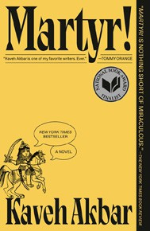



Kaveh Akbar, Vintage, $18
- Funny Story
Emily Henry, Berkley, $19
- The Frozen River
Ariel Lawhon, Vintage, $18
- Orbital
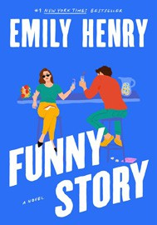

Samantha Harvey, Grove Press, $17
- Demon Copperhead
Barbara Kingsolver, Harper Perennial, $21.99
- Fourth Wing
Rebecca Yarros, Entangled: Red Tower Books, $20.99
- Parable of the Sower
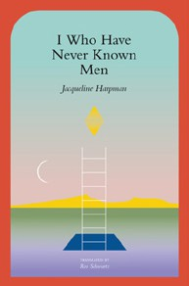

Octavia E. Butler, Grand Central, $19.99
- Deep End
Ali Hazelwood, Berkley, $20
- North Woods
Daniel Mason, Random House Trade Paperbacks, $18
- The Handmaid’s Tale
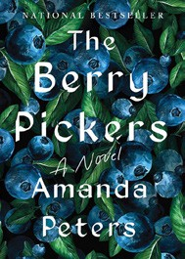

Margaret Atwood, Anchor, $18
- A Court of Thorns and Roses
Sarah J. Maas, Bloomsbury Publishing, $19
- I Who Have Never Known Men
Jacqueline Harpman, Transit Books, $16.95
- The Housemaid
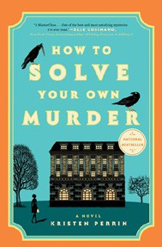

Freida McFadden, Grand Central, $12.99
- The Crash
Freida McFadden, Poisoned Pen Press, $17.99
- The Berry Pickers
Amanda Peters, Catapult, $17.95
17 How to Solve Your Own Murder

Kristen Perrin, Dutton, $18

OTHER PAPERBACK INDIE FAVORITES
Go Luck Yourself: A Royals and Romance Novel


Sara Raasch, Bramble, $19.99
“Go Luck Yourself is absolutely everything I could have hoped for in a sequel to The Nightmare Before Kissmas. I was delighted to see Kris’ inner workings and his quest for his own happily ever after, and I adored Lochlann and his sisters.”
—Emily Hall Schroen, Main Street Books, St. Charles, MO
April 2, 2025
For the week ending March 30, 2025 based on sales in hundreds of independent bookstores nationwide.
PAPERBACK

RANK | NONFICTION
- On Tyranny: Twenty Lessons from the Twentieth Century
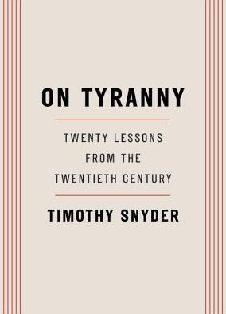

Timothy Snyder, Crown, $12
- The Wager
David Grann, Vintage, $21
- Braiding Sweetgrass
Robin Wall Kimmerer, Milkweed Editions, $20


- The Backyard Bird Chronicles
Amy Tan, Knopf, $36
- The Art Thief
Michael Finkel, Vintage, $18
- All About Love: New Visions
bell hooks, Morrow, $16.99
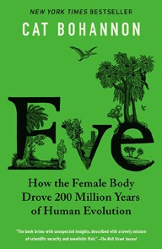

- Eve
Cat Bohannon, Vintage, $20
- A Dumb Birds Field Guide to the Worst Birds Ever
Matt Kracht, Chronicle Books, $15.95
- The Portable Feminist Reader

Roxane Gay (Ed.), Penguin Classics, $25
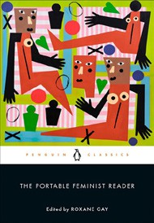

- The Body Keeps the Score
Bessel van der Kolk, M.D., Penguin, $19
- On Tyranny Graphic Edition
Timothy Snyder, Nora Krug (Illus.), Ten Speed Graphic, $16.99
- The Hundred Years’ War on Palestine


Rashid Khalidi, Metropolitan Books, $19.99
- The Artist’s Way: 30th Anniversary Edition
Julia Cameron, TarcherPerigee, $20
- A People’s History of the United States
Howard Zinn, Harper Perennial Modern Classics, $22.99
- There’s Always This Year: On Basketball and Ascension

Hanif Abdurraqib, Random House Trade Paperbacks,
$20 Debut
On the Rise


MASS MARKET Indies Introduce
- 1984 George Orwell, Signet, $10.99
- Animal Farm George Orwell, Signet, $9.99
- The Diary of a Young Girl Anne Frank, Bantam, $8.99
- The Way of Kings Brandon Sanderson, Tor, $12.99
- Mistborn: The Final Empire Brandon Sanderson, Tor, $10.99
- Dune Frank Herbert, Ace, $10.99
- Slaughterhouse-Five Kurt Vonnegut, Laurel Leaf, $9.99
- The Exchange John Grisham, Vintage, $10.99
- It Can’t Happen Here Sinclair Lewis, Signet, $10.99
- Lord of the Flies William Golding, Penguin, $12

